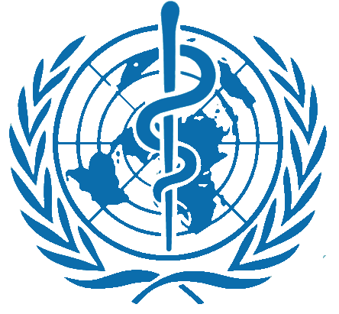
2016 International Symposium on Vulnerable Population & Environmental Health in the Asia Pacific Region
WHO Collaborating Centre for
Vulnerable Population and Environmental Health

Lotte City Hotel Gimpo Airport, Seoul, Republic of Korea
10 – 11 March, 2016
Day 1 Thursday, 10 March 2016
09:00 – 09:30 | Registration
09:30 – 10:00 | Opening Ceremony (Chair : Daeseon Kim, NIER)
Opening Address
Dr. Jin-Won Park (President, National Institute of Environmental Research, Republic of Korea)
Congratulatory Address
Mr. Ho-Joong Lee (Director General, Ministry of Environment, Republic of Korea)
Session 1 | Importance of Vulnerable Population in Environmental Health with Sustainable Development (Chair : Seungdo Yu, NIER)
10:00-10:30 | Importance of Vulnerable Population and Environmental Health Strategy by WHO WPRO  Dr. Mohd.Nasir Hassan (WHO Regional office for the Western Pacific)
10:30 – 11:00 | Environmental Geochemistry and Human Health Issues in Asia  Prof. Kyoung-Woong Kim (Gwangju Institute of Science and Technology)
11:00 – 11:30 | Environmental Health Issues in Vulnerable Areas, Mongolia  Dr. Tsogtbaatar Byambaa (Public Health Institute of Mongolia)
11:30 – 12:00 | Environmental Health Issues in Korea  Prof. Byung Sun Choi (Chung-Ang University)
12:00 – 13:30 | Lunch
Session 2 | Recent Environmental Health Issues in the Asia Pacific Region (I)  (Chair : Tsogtbaatar Byambaa, PHI)
13:30 - 14:00 | Exposure assessments of cadmium, lead and arsenic and the health effects among vulnerable populations in Japan and Pakistan  Prof. Fujio Kayama (Jichi Medical University, Japan)
14:00 – 14:30 | Occupational and Environmental Health in Mining in Vietnam  Dr. Nguyen Dinh Trung (National Institute of Occupational and Environmental Health)
14:30 – 15:00 | Ongoing study and Health issues of residents living near abandoned metal mines in Korea  Prof. Young-Seoub Hong (Dong-A University)
15:00 – 15:30 | Environmental Health Risks and Challenges in Small Scale Mining Areas in the Philippines  Prof. Vivien Fadrilan-Camacho (University of the Philippines Manila)
15:30 – 15:50 | Break Time
Recent Environmental Health Issues in the Asia Pacific Region (II)
(Chair : Yun-Chul Hong, Seoul National University)
15:50 – 16:20 | Challenges of Environmental Health Risk Management of Tailings Storage Facilities of an Old Gold Mine in the Solomon Islands  Dr. Rokho Kim (WHO office in the South Pacific)
16:20 – 16:50 | Environmental challenges and conditions around the gold mining areas in Indonesia  Prof. Markus Talintukan LASUT (Sam Ratulangi University, Indonesia)
16:50 – 17:20 | Current Status of Environmental Health Issues/Challenges in Cambodia  Mr. CHHUN Seiha (Ministry of Environment, Cambodia)
17:20 – 18:00 | Discussion (Chair : Kyoung-woong Kim)  Speaker : Prof. Heon Kim (Chungbuk National University), Prof. Hae-Kwan Cheong  (Sungkyunkwan University), Prof. Yun-Chul Hong (SNU)
18:00 – | Banquet
Day 2 Friday, 11 March 2016
09:30- | Discussion for Further Cooperation

