PARADISE HOTEL BUSAN  RESERVATION FORM |  | 2023 환경독성보건학회 추계학술대회  2023. 11. 8(수) - 10(금) |  |  |  | 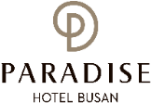
*Check-In Date: |  |  | *Check-Out Date: |  |  | 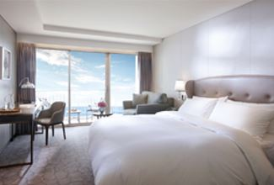  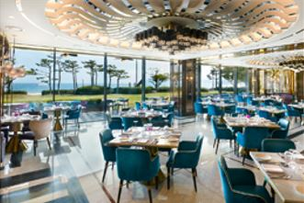  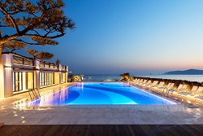
*No. of Persons:
*Name (Family/Given):
*Telephone: |  |  | *E-mail:
*PAYMENT INFORMATION (In order to guarantee your reservation, credit card information must be accompanied)
*Credit Card: ☐Other ☐Visa ☐Masters ☐Amex(4digit-number: )
*Credit Card Number:
*Expiry Date(MM/YY): |  |  | *Card Holder’s Name:
*SPECIAL ROOM RATES (Room Only) (Unit: Korean Won)
Room Type |  |  | *Monday ~ Thursday | *Friday | *Saturday |  | *Sunday
Annex Bldg.  (신관) | Deluxe City View |  | ☐ \254,100 (Double Bed)  ☐ \254,100 (Twin Beds) | Surcharge  \72,600  (주중대비  인상요금) | Surcharge  \145,200  (주중대비  인상요금) |  | Surcharge  \36,300  (주중대비  인상요금)
Annex Bldg.  (신관) | Deluxe Ocean View |  | ☐ \278,300 (Double Bed)
Main Bldg.  (본관) | Deluxe Ocean Terrace View |  | ☐ \302,500 (Double Bed)  ☐ \302,500 (Twin Beds)
Annex Bldg.  (신관) | Deluxe Ocean Terrace View |  | ☐ \326,700 (Double Bed)  ☐ \326,700 (Twin Beds)
* Breakfast Buffet (Main Bldg. 1F. On the Plate, 06:30~10:00): \50,000/Person, ☐ Extra Bed/Bedding: \72,600/Night
* Special Request :
* The above mentioned room reservations may be closed in advance. (예약은 사전 마감 될 수 있음)
* The rates above are non-commissionable, and they are Inclusive of 10% Service Charge and 11% Government Tax. (세금 및 봉사료 포함)
* The rates above are not inclusive of breakfast. (조식 미포함)
* Number of guests: 2 Adults (기준인원: 성인 2인, 단 소인 2인까지 추가요금 없이 숙박 가능)/ All rooms of the Building are non-smoking areas
* Check-in time is 3p.m.(15h00) Check-out time is 11:00 a.m.(11h00). Past the mentioned check-out time, the following rates will be applied
(Until 3p.m.(15h00): 50% of the room rate, After 3p.m.(15h00): 100% of the room rate) (체크인 오후 3시부터, 체크아웃 오전 11시까지)
* Benefits Included: Outdoor Ocean pool(Swimming pool), Fitness Club, Business Center, Paradise Kids Villages, Wi-Fi
* The Leisure facilities(Ocean Pool, Fitness Club, Sauna, Spa ‘Cimer’) will be closed for maintenance every fourth Wednesday each month.
CANCELLATION POLICY
* Amendaments, Cancellations are availble upon following regulations: Hotel has the right to claim all room charge, which would be deducted from your guaranteed credit card. Cancellation or No-Show after the room reservation is being charged as below:
- From 5days to 3days prior to Arrival date(~18:00): 50% of the Room charge (체크인 5일 전 ~ 3일 전 : 숙박료의 50% 위약금 부과)
- From 2days or less prior to Arrival date(Includling No-Show): 100% of the Room chrarge (체크인 2일 전 ~ 당일 : 숙박료의 100% 위약금 부과)
Please send your reservation form to: res@paradisehotel.co.kr (Tel. +82-51-749-2111~3)

